School District Analysis

Alex Young

Two clear findings:

1. Charter Schools tended to perform better than district schools, despite having less funding per student on average.

As we can see, charter schools have much higher passing rates than their district counterparts:

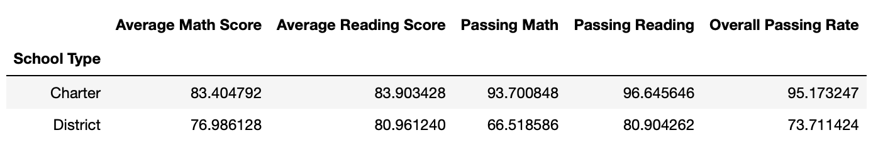

Also, schools that spent less money per student, had higher passing rates than those that spent $615 or more per student.

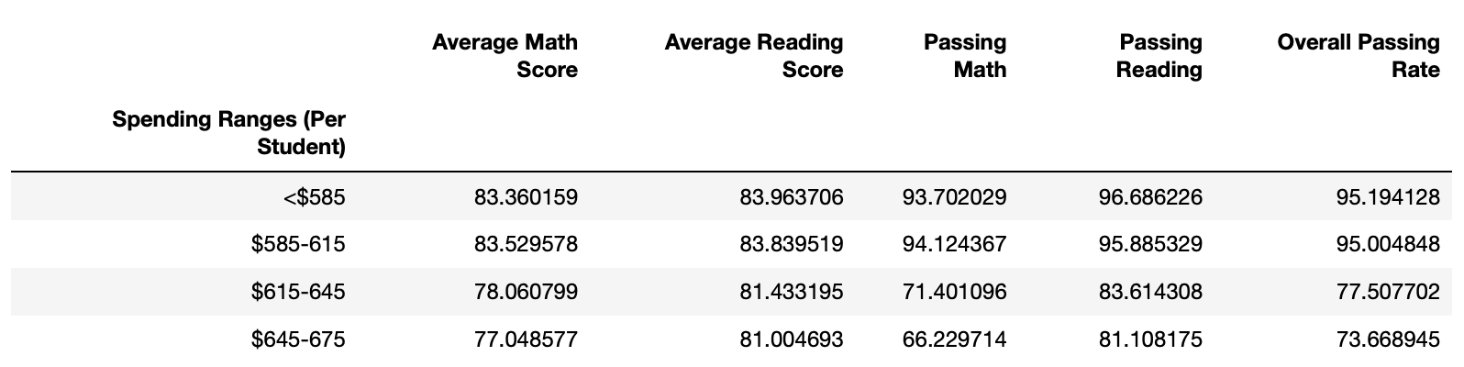

Yet, we can also see that a lot of the schools with lower spending ranges are also charter schools:

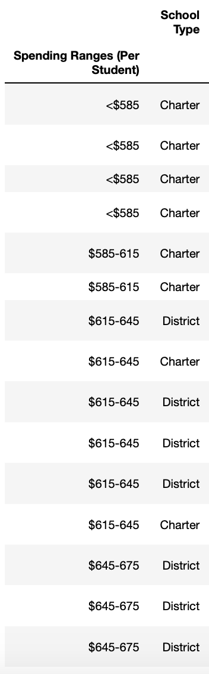

Essentially, charter schools tend to have smaller budgets and tend to have higher passing rates (even though their math and reading scores are only 7 and 3 points lower on average than district schools).

1. Small and medium-size schools have significantly higher passing rates on average than larger schools (and a lot of these smaller schools are charter schools).

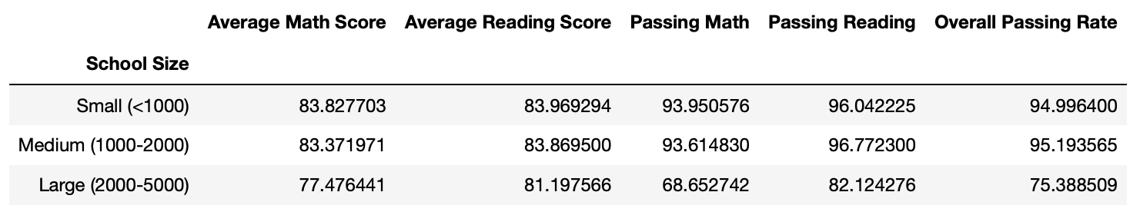

It appears that large school size is negatively correlated with overall passing rate, and that these large schools bigger budgets fail to remedy the problem. The charter school model seems to be correlated with higher passing rates, yet we need to know more to figure out why and whether we can mimic those results at the district level. In this district, it’s hard to isolate variables because there aren’t any large charter schools, nor large schools with lower budgets. Seeing those types of schools would make us better able separate what characteristics of these schools seem to drive success.

However, I would like to know more about how these charter schools are created. Perhaps these are magnet schools. Perhaps students have to pass an entrance exam to get in. In that case, perhaps these small charter schools have better numbers because they are able to keep struggling students out, or cherry pick the best students from districts. Self-selection bias can inflate private school numbers, and it’ll be interesting to see if there’s any sort of self-selection bias with charter schools.